

MEDIA RELEASE

AURORA EXPEDITIONS MARKS 35 YEARS OF EXPLORATION WITH
GLOBAL ANNIVERSARY OFFER ACROSS ANTARCTICA, THE ARCTIC AND BEYOND
Anniversary savings of up to 35% available on selected expeditions in 2026 and 2027.

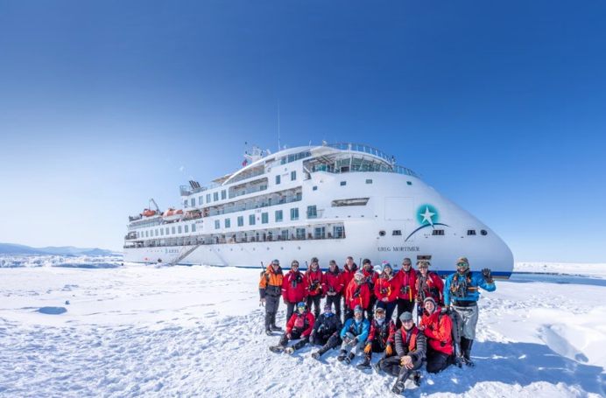
Download Images here

New York, UNITED STATES — 6 January 2026 - Aurora Expeditions is marking 35 years of pioneering expedition travel with a special 35th anniversary offer, featuring savings of up to 35% on a selection of thoughtfully curated expeditions across Antarctica, the Arctic and Small Ship journeys through culturally rich coastlines and remote island regions in 2026 and 2027.

Founded in Australia in 1991 by mountaineering legend Greg Mortimer, Aurora Expeditions has spent more than three decades designing immersive journeys to the world’s most remote and remarkable places. Purpose-built small ships, expert expedition teams and a strong commitment to responsible exploration define Aurora’s approach — offering travellers deeper access, richer experiences and a genuine connection to the environments they explore.

Designed for curious and adventurous travellers, Aurora’s expeditions combine active exploration, meaningful education and exceptional access, guided by specialists who are leaders in their fields. This anniversary offer reflects Aurora’s long-standing philosophy of exploration with purpose, care and respect for the natural world.

ANTARCTICA EXPEDITIONS
Travellers can take advantage of the anniversary offer across selected Antarctic expeditions, experiencing deep immersion, expert-led exploration and some of the most wildlife-rich regions on Earth.

Spirit of Antarctica
27 February – 10 March 2027 | 12 days
From $19,059 per person* (previously from $29,321)
A comprehensive Antarctic Peninsula expedition featuring daily Zodiac landings, towering icebergs, abundant wildlife and immersive exploration led by Aurora’s expert expedition team.

Wild Antarctica featuring the Weddell Sea
2 March – 14 March 2027 | 13 days
From $22,387 per person* (previously from $34,442)
A rare opportunity to explore the remote Weddell Sea, known for its vast ice shelves and emperor penguin habitat, enriched by expert scientific insight through Aurora’s partnership with New Scientist Discovery Tours.

South Georgia, Falklands & Antarctic Odyssey
9 March – 29 March 2027 | 21 days
From $32,676 per person* (previously from $50,270)
An epic Southern Ocean voyage combining the wildlife spectacle of South Georgia, the Falkland Islands and the Antarctic Peninsula, delivering some of the most extraordinary wildlife encounters on the planet.

In Shackleton’s Footsteps
8 November – 27 November 2026 | 20 days
From $33,886 per person* (previously from $48,408)
A historic expedition retracing Sir Ernest Shackleton’s legendary journey, blending polar exploration with powerful storytelling and Antarctic heritage.

ARCTIC EXPEDITIONS & BEYOND
From the North Atlantic to remote island regions, Aurora’s Arctic expeditions combine expedition expertise with cultural discovery and spectacular natural landscapes.

Historical Trails & Wilderness: Scotland, Faroes & Iceland
17 May – 29 May 2026 | 13 days
From $14,297 per person* (previously from $21,995)
A journey through rugged North Atlantic landscapes, blending Viking history, dramatic coastlines and remote island communities.

Iceland: Into the Westfjords
9 June – 15 June 2026 | 7 days
From $9,747 per person* (previously from $14,995)
An in-depth exploration of Iceland’s remote Westfjords, known for dramatic fjords, seabird colonies and geothermal landscapes.

Arctic Golden Autumn & Northern Lights
18 August – 3 September 2026 | 17 days
From $20,732 per person* (previously from $31,895)
Timed for autumn colour and aurora activity, this Arctic expedition combines wilderness exploration with opportunities to witness the Northern Lights.

Idyllic Raja Ampat & Cenderawasih Bay
5 October – 14 October 2026 | 10 days
From $20,732 per person* (previously from $31,895)
An expedition into one of the world’s most biodiverse marine regions, featuring snorkelling, coral reefs, whale shark encounters and remote island exploration.

SMALL SHIP CRUISES
Aurora’s Small Ship journeys offer expedition-style discovery closer to home, combining cultural immersion, historic routes and access to remote coastlines.

Madrid to Marrakech: An Atlantic Adventure
10 June – 24 June 2026 | 15 days
From $13,907 per person* (previously from $21,395)
A journey along the Atlantic coast linking Europe and North Africa, featuring historic ports, cultural encounters and scenic coastal exploration.

A Mediterranean Masterpiece
30 June – 12 July 2026 | 13 days
From $13,062 per person* (previously from $20,095)
An art, history and culture-rich voyage through the Mediterranean, blending iconic destinations with lesser-visited ports and immersive shore experiences.

The Godfather
8 July – 19 July 2026 | 12 days
From $12,217 per person* (previously from $18,795)
A cinematic journey through Sicily and southern Italy, inspired by the landscapes, villages and history made famous in The Godfather films.

An Adriatic Renaissance
17 July – 28 July 2026 | 12 days
From $11,372 per person* (previously from $17,495)
Explore the cultural heart of the Adriatic, from medieval old towns to island-dotted coastlines, with a focus on history, architecture and local life.

Sailing the Greek Islands
29 August – 9 September 2026 | 12 days
From $13,452 per person* (previously from $20,695)
An immersive exploration of the Greek Islands, combining ancient history, island culture and stunning seascapes aboard a small expedition ship.

To take advantage of the 35th anniversary offer and be part of Aurora Expeditions’ next chapter of exploration, visit www.aurora-expeditions.com
~ENDS~

*Sale is available now until 31 March 2026 unless sold out prior. Pricing based on per person twin share entry cabin and applies to cabin fare only.

MEDIA CONTACT:

Agency Contact

Madeline Georgiadis
Global Director, PR & Communications
mgeorgiadis@aurora-expeditions.com

About Aurora Expeditions
Aurora Expeditions is an award-winning Australian-owned adventure travel company that has pioneered experiential travel for 35 years. A Certified B Corporation™️, a commitment to the protection and preservation of our planet is at the heart of each experience.

Founded on the guiding principles of adventure and endless exploration, our carefully curated small-ship voyages offer immersive activities, more time off ship and thoughtful enrichment programs in some of the planet’s most remote and incredible places.
Aurora’s three purpose-built small ships, Greg Mortimer, Sylvia Earle and Douglas Mawson are designed for global discovery.

